JAVASCRIPT BY CODE WITH HARRY
CHAPTER 1
1)
<!-- Create a variable of type string and try to add a number to it. -->

console.log("addition of 3 numbers");
function add(a, b, c) {
return a + b + c;
}
let x = add(1, 2, 25);
console.log(x);
Let name= "Harry";
Let age= 29;
console.log(name+ age);

2)
console.log("This repl contains code for the Ultimate JavaScript course video no 2")
var a = 67 // a contains 67
console.log(a)
a = "harry"
console.log(a)
// let 8harry = 7 // Not allowed this will throw an error
// let var = 7
3)
var is globally scped
var b = "Harry";
{
var b = 'this'
console.log(b)
}
console.log(b)
output: this,this
let and const are block scoped
let b = "Harry";
{
let b = 'this'
console.log(b)
}
console.log(b)
output: this,Harry
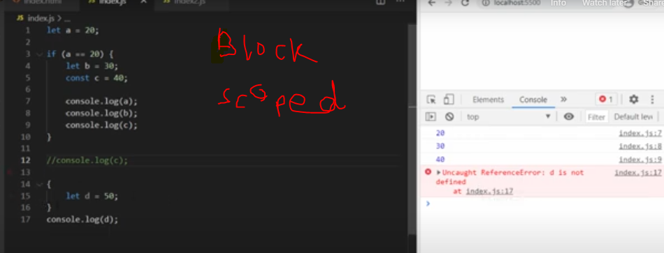

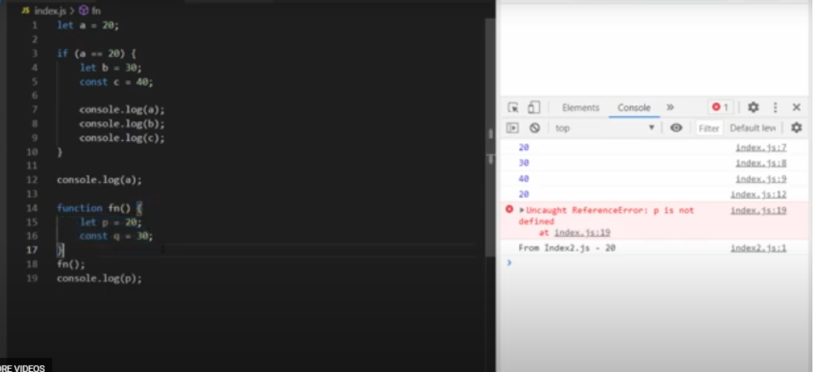
Blocked scope
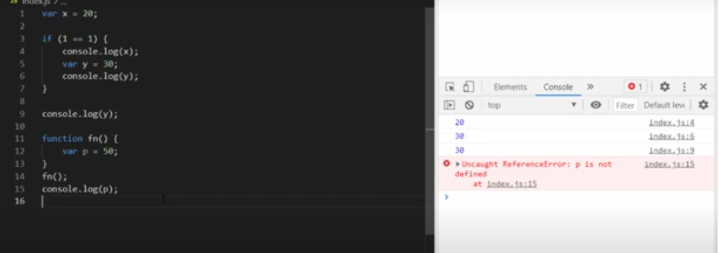
4)
// nn bb ss u - Primitives in Js
let a = null;
let b = 345;
let c = true; // can also be false
let d = BigInt("567") + BigInt("3")
let e = "Harry"
let f = Symbol("I am a nice symbol")
let g =undefined;
// let g;
console.log(a, b, c , d, e, f, g)
console.log(typeof c)

// Non Primitive Data Type - Objects in Js
const item = {
"Harry": true,
"Shubh": false,
"Lovish": 67,
"Rohan": undefined
}
console.log(item["Shubh"])

5)
Q1: Adding numbers to strings
let name = "Harry";
let age = 29;
console.log(name + age);
harry29
Q2: Using typeof
console.log(typeof name); // "string"
console.log(typeof age); // "number"

Q4: Modifying const objects
Try to add a new key to the previous const object.

const biodata = {
name: "Harry",
age: 30
};
biodata.address = "123 Main St";
console.log(biodata); // { name: "John", age: 30, address: "123 Main St" }

Q5: Month dictionary
const months = {
1: "January",
2: "February",
3: "March",
4: "April",
5: "May",
6: "June",
7: "July",
8: "August",
9: "September",
10: "October",
11: "November",
12: "December"
};
Console.log(months);

CHAPTER 2
6)
let a = 10;
let b = 4;
console.log("a + b = ", a + b)
console.log("a - b = ", a - b)
console.log("a / b = ", a / b)
console.log("a ** b = ", a ** b)
console.log("a % b = ", a % b)
console.log("++a = ", ++a)

// agy wala ++ just print krwata hai

console.log("a++ = ", a++)
console.log("--a = ", --a)
console.log("a-- = ", a--)
console.log("a = ", a)
console.log("a-- = ", a--)
a + b = 14
index.js:8
a - b = 6
index.js:9
a / b = 2.5
index.js:10
a ** b = 10000
index.js:11
a % b = 2
index.js:12
++a = 11
index.js:13
a++ = 11
index.js:17
--a = 11
index.js:18
a-- = 11
index.js:19
a = 10
index.js:20
a-- = 10

// Comparison Operators
let comp1 = 6;
let comp2 = "6";
// let comp2 = 7;
console.log("comp1 == comp2 is ", comp1 == comp2)
console.log("comp1 != comp2 is ", comp1 != comp2)
// check data type
console.log("comp1 === comp2 is ", comp1 === comp2)
console.log("comp1 !== comp2 is ", comp1 !== comp2)
console.log("comp1 > comp2 is ", comp1 > comp2)

// Logical Operators
let x = 5;
let y = 6;
console.log(x<y && x==5)
console.log(x>y || x==5)
console.log(!false)
console.log(!true)

// Assignment Operators
let assignment = 1;
assignment += 5 // same as assignment = assignment + 5
console.log("a is now = ", a)
assignment -= 5 // same as assignment = assignment - 5
console.log("a is now = ", a)
assignment *= 5 // same as assignment = assignment * 5
console.log("a is now = ", a)
assignment /= 5 // same as assignment = assignment / 5
console.log("a is now = ", a)

7)
// The alert() method is used when you want information to come through to the user.
let a = prompt("Hey whats you age?");
a = Number.parseInt(a); // Converting the string to a number
if(a<0)
{
alert("This is an invalid age");
}
else if(a<9)
{
alert("You are a kid and you cannot even think of driving");
}
else if(a<18 && a>=9)
{
alert("You are a kid and you can think of driving after 18");
}
else
{
alert("You can now drive as you are above 18");
}
console.log("Done")
// HomeWork - Explore switch statement and write a basic program in the comments
console.log("You can", (a<18? "not drive" :"drive"))

8)
// Problem No 1
let age = prompt("What is your age?")
age = Number.parseInt(age)
if (age > 10 && age < 20)
{
console.log("Your age lies between 10 and 20")
}
else
{
console.log("Your age doesnt lies between 10 and 20")
}

// Problem No 2
let age = prompt("What is your age?")
switch (age) {
case '12':
console.log("Your age is 12")
break
case '13':
console.log("Your age is 13")
break
case '14':
console.log("Your age is 14")
break
case '15':
console.log("Your age is 15")
break
default:
console.log("Your age is not special")
}

Problem No 3
let num = prompt("What is your age?")
num = Number.parseInt(num)
if (num % 2 == 0 && num % 3 == 0) {
console.log("Your number is divisible by 2 and 3")
}
else {
console.log("Your number is not divisible by 2 and 3")
}

CHAPTER 3
9)
// Program to add first n natural numbers
let sum = 0
let n = prompt("Enter the value of n")
n = Number.parseInt(n)
for (let i = 0; i < n; i++) {
sum += (i + 1)
// console.log((i+1), "+")
}
console.log("Sum of first " + n + " natural numbers is " + sum)
// console.log(i)

let obj = {
harry: 90,
shubh: 45,
shivika: 56,
ritika: 57,
shiv: 23
}

// For in loop
for (let a in obj) {
console.log("Marks of " + a + " are " + obj[a])
}

// For of loop
const array = [1, 2, 3, 4, 5];
for (let element of array) {
console.log(element);
}

// 1. ITERATING AN OBJECT
let obj = {
name: "Harry",
language: "JavaScript",
hobbies: "Android app development"
}
// 1.2 Iterating an object using for-in loop:
for (let key in obj){
console.log(obj[key]);
}
// 2. ITERATING A STRING
// We can use for in with strings to loop through all the characters
myString = "This is my string";
for (let char in myString){
console.log(myString[char]);
}

// **********For of loop***********
console.log("*****************For of loop starts here**************")
people = ["Harry", "Rohan", "SkillF", "Shubham", "Vikrant"];

for(let name of people){
console.log(name);
}

for(let name of "myString"){
console.log(name);
}

10)
// do while loop
let n = prompt("Enter the value of n")
n = Number.parseInt(n)

let i = 10;
do{
console.log(i)
i++;
}while (i < n)

// while loop
let n = prompt("Enter the value of n")
n = Number.parseInt(n)
let i = 0;
while(i<n){
console.log(i)
i++;
}

11)
FUNCTIONS
//Arrow function
const sum = (p, q) => {
return p + q
}

// Regular function
const sum = function (p, q) {
return p + q;
};

// REGULAR FUNCTION
function sum(a,b)
{
return a+b
}

console.log(sum(9,3))

CHAPTER 4
13,14,15)
let name = "Harry"
// console.log(name.length)
console.log(name[0])
console.log(name[1])
let friend = 'Prakash'
console.log(friend)

// Escape Sequence Characters
// let fruit = 'Bana\'na'
// console.log(fruit)
let fruit = "Bana\"na"
console.log(fruit)

STRING METHODS
let name = "Harry"
console.log(name.length)

console.log(name.toUpperCase())
console.log(name.toLowerCase())
console.log(name.slice(2, 4))
console.log(name.slice(2))
console.log(name.replace("Har", "Per"))
let friend = "Naman"
console.log(name.concat(" is a friend of ", friend))
let friend2 = " Meena "
console.log(friend2)
console.log(friend2.trim())

let fr = "Raman" + "Shivika" + "Harry"
console.log(fr[0])
console.log(fr[1])
console.log(fr[2])
console.log(fr[3])
console.log(fr[9])
// fr[4]= "o" // This is not possible
console.log(fr)

// Chapter 4 - Practice Set
// Problem 1
let str = "Har\""
console.log(str.length)

// Problem 2
const sentence = 'The quick brown fox jumps over the lazy dog.';
const word = 'fox2';
console.log(sentence.includes(word))
console.log(`The word "${word}" ${sentence.includes(word) ? 'is' : 'is not'} in the sentence`);

// Problem 3
console.log(word.toLowerCase())
console.log(word.toUpperCase())

// Problem 4
let str2 = "Please give Rs 1000"
let str2 = Number.parseInt(str2.slice(15))
console.log(str2)
console.log(typeof str2)

// Problem 5
let friend = "Deepika"
friend[3] = "R"
console.log(friend) // friend is not changed, because string is immutable

CHAPTER 5
16)
ARRAYS
let marks_class_12 = [91, 82, 63, 84, false, "Not Present"]
console.log(marks_class_12[0])
console.log(marks_class_12[1])
console.log(marks_class_12[2])
console.log(marks_class_12[3])
console.log(marks_class_12[4])
console.log(marks_class_12[5])
console.log(marks_class_12[6]) // Will be undefined because index 6 does not exist
console.log("The length of marks_class_12 is", marks_class_12.length)
marks_class_12[6] = 89 // Adding a new value to the array
marks_class_12[0] = 96 // Changing the value of an array
console.log(marks_class_12)
console.log(typeof marks_class_12)

17,18)
ARRAYS METHODS
BASIC SYNTAX
let num = [1, 2, 3, 34, 4]
let b = num.toString() // b is now a string

// Array Methods
let num = [1, 2, 3, 34, 4]
let b = num.toString() // b is now a string
console.log(b, typeof b)
let c = num.join(" and ")
console.log(c, typeof c)

// pop returns the popped element
let s = num.pop()
console.log(num, s)//

// push returns the new array length
let r = num.push(56)
console.log(num, r)

let t = num.shift()
// Removes an element from the start of the array
console.log(t, num)

// ADD an element from the start of the array
let u = num.unshift(78)
console.log(u, num)
console.log(u)

let num = [1, 2, 3, 4, 5, 6, 7, 8, 9]
let num_more = [11, 12, 13, 14, 15, 16, 17, 18, 19]
let num_even_more = [211, 212, 213, 214, 415, 416, 417, 418, 419]
console.log(num.length)
delete num[0]
// console.log(num.length)

// let newArray = num.concat(num_more, num_even_more)
// console.log(newArray)
// console.log(num, num_more)

// sort method
let numbers = [4, 2, 5, 1, 3];
numbers.sort(function(a, b)
{
return b - a;
});
console.log(numbers);
// num1.reverse()
// console.log(num1)

// Splice and Slice
let num2 = [551, 22, 3, 14, 5, 6, 7, 8, 229]
let deletedValues = num2.splice(2, 4, 1021, 1022, 1023, 1024, 1025)
console.log(num2)
console.log(deletedValues)

// let newNum = num.slice(3)
let newNum = num.slice(3, 5)
console.log(newNum)

FOR EACH LOOP
It is easy way of printing arrays without taking extra variable.it calls a function once for each array element.

let numbers = [1, 2, 3, 4, 5];
numbers.forEach(function(number, index) {
console.log("Element at index " + index + ": " + number);
});
Element at index 0: 1
Element at index 1: 2
Element at index 2: 3
Element at index 3: 4
Element at index 4: 5

FOR IN LOOP
variable: A variable that will be assigned the property name on each iteration.
object: The object whose enumerable properties will be iterated over.

let obj = {
harry: 90,
shubh: 45,
shivika: 56,
ritika: 57,
shiv: 23
}
for (let a in obj) {
console.log("Marks of " + a + " are " + obj[a])
}
// 1. ITERATING AN OBJECT
let obj = {
name: "Harry",
language: "JavaScript",
hobbies: "Android app development"
}
// 1.2 Iterating an object using for-in loop:
for (let key in obj){
console.log(obj[key]);
}
// 2. ITERATING A STRING
// We can use for in with strings to loop through all the characters
myString = "This is my string";
for (let char in myString){
console.log(myString[char]);
}

FOR OF LOOP
variable: A variable that will be assigned the value of each element in the iterable on each iteration.
iterable: An iterable object (e.g., array, string, map, set) to be iterated over.

people = ["Harry", "Rohan", "SkillF", "Shubham", "Vikrant"];

for(let name of people){
console.log(name);
}

for(let name of "myString"){
console.log(name);
}

const array = [1, 2, 3, 4, 5];
for (let element of array) {
console.log(element);
}

ARRAY.FROM
It is used to create an array from any other object
let name="allyan"
let a=array.from(name)
console.log(a)
output
[‘a’,’l’,’l’,’y’,’a’,’n’]

ARRAY.MAP
Create a new array by applying function in each array element
const numbers = [1, 2, 3, 4, 5];

const doubledNumbers = numbers.map((numbers) => {
return numbers * 2;
});

console.log(doubledNumbers); // Output: [2, 4, 6, 8, 10]

ARRAY FILTER METHOD

const numbers = [1, 2, 3, 4, 5];
const evenNumbers = numbers.filter((number) => {
return number % 2 === 0;
});

ARRAY REDUCE METHOD

const numbers = [1, 2, 3, 4, 5];
const sum = numbers.reduce((accumulator, currentValue) => {
return accumulator + currentValue;
}, 0);

console.log(sum); // Output: 15

